19.)WAP to input electricity unit charges and calculate total electricity bill according to the given condition:For first 50 units Rs. 0.50/unit,For next 100 units Rs. 0.75/unit,For next 100 units Rs. 1.20/unit,For unit above 250 Rs. 1.50/unit,An additional surcharge of 20% is added to the bill.

int main()

{

int units,cost;

cout<<"Total number of units";

cin>>units;

if(units<=50)

{

cost=units*0.5;

cout<<"Total bill is"<<cost;

}

else if(units<=150)

{

cost=units*0.75;

cout<<"Total bill is"<<cost;

}

else if(units<=250)

{

cost=units*1.2;

cout<<"Total bill is"<<cost;

}

else

{

cost=units*1.5;

cost = cost*1.2;

cout<<"Total bill is"<<cost;

}

return 0;

}

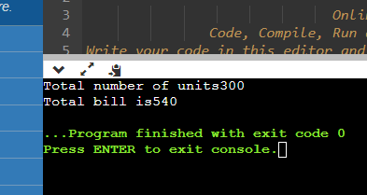

18.)WAP to input basic salary of an employee and calculate its Gross salary according to following:Basic Salary <= 10000 : HRA = 20%, DA = 80%,Basic Salary <= 20000 : HRA = 25%, DA = 90%,Basic Salary > 20000 : HRA = 30%, DA = 95%.

int main()

{

float basic,gross,da ,hra;

cout<<"enter the basic salary of an employee";

cin>>basic;

if(basic<=10000)

{

hra=basic*0.2;

da=basic*0.8;

}

else if(basic<=20000)

{

hra=basic*0.25;

da=basic*0.90;

}

else

{

hra=basic*0.3;

da=basic*0.95;

}

gross = basic + hra + da;

cout<<"gross salary is"<< gross;

return 0;

}

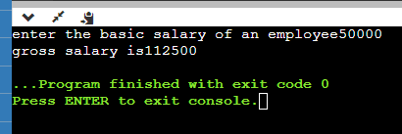

17.)WAP to check whether a number is divisible by 5

#include<iostream>

using namespace std;

int main()

{

int num;

cout<<"Enter a number";

cin>>num;

if(num%5 == 0)

cout<<"number is divisible by 5";

else

cout<<"number is not divisible by 5";

return 0;

}

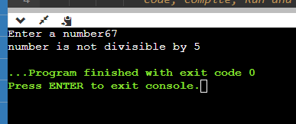

16.)Write a program that will give the grade of the student based on the percentage he got in the course. Use the following criteria for assigning grades:Grade = A ( when percentage >= 60)

Grade = B ( when percentage >= 50 and percentage < 60),Grade = C ( when percentage >= 40 and percentage < 50),Grade = D ( when percentage >= 30 and percentage < 40),Grade = E ( when percentage >= 20 and percentage < 30).

int main()

{

float marks;

cout<<"Enter your marks";

cin>>marks;

if(marks>=60)

{

cout<<"GRADE A";

}

else if(marks>=50 && marks<60)

{

cout<<"GRADE B";

}

else if(marks>=40 && marks<50)

{

cout<<"GRADE C";

}

else if(marks>=30 && marks<40)

{

cout<<"GRADE D";

}

else

{

cout<<"GRADE E";

}

return 0;

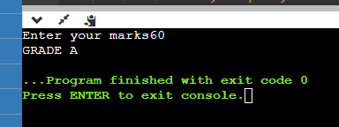

15.) WAP to calculate a bike’s average consumption from the given total distance (integer value) travelled (in km) and spent fuel.Test Data: Input total distance in km: 350 ,Input total fuel spent in litres: 5 ,Expected Output:,Average consumption (km/lt) 70.00

#include<iostream>

using namespace std;

int main()

{

int distance,consume;

float avg;

cout<<"Enter the total distance";

cout<<"Enter the total consumption";

cin>>distance>>consume;

avg=distance/consume;

cout<<avg;

return 0;

}

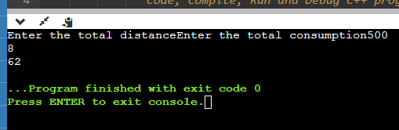

14.)WAP for two item’s weight (floating points' values) and number of purchase (floating points' values) and calculate the average value of the items.

Test Data: ,Weight - Item1: ,15No. of item1: 5 ,Weight - Item2: 25 ,No. of item2: 4   
Expected Output:,Average Value = 19.444444

#include<iostream>

using namespace std;

int main()

{

float witem1,witem2,nitem1,nitem2,avg;

cout<<"Enter number of items and their weight";

cin>>witem1>>witem2>>nitem1>>nitem2;

avg = witem1*nitem1+witem2*nitem2/nitem1+nitem2;

cout<<avg;

return 0;

}

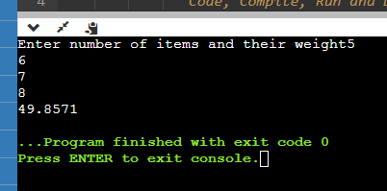

13.)WAP to calculate Area and Circumference of Circle.

#include<iostream>

using namespace std;

int main()

{

double radius,circumference,area;

cout<<"Enter the radius and circumference";

cin>>radius>>circumference;

area=3.14*radius*radius;

circumference=2*3.14*radius;

cout<<"Area of a circle is:"<<area;

cout<<"Circumference of a circle is:"<<circumference;

return 0;

}

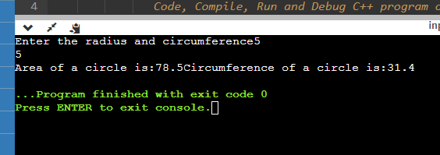

12.)WAP to calculate the area of Triangle.

#include<iostream>

using namespace std;

int main()

{

int base,height;

float ans;

cout<<"Enter the base and height";

cin>>base>>height;

ans=(0.5)*height*base;

cout<<"Area of a triangle is:"<<ans;

return 0;

}

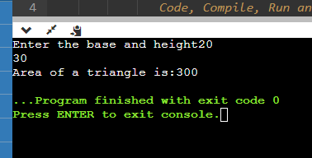

11.)WAP to calculate Area of Square.

#include <iostream>

using namespace std;

int main()

{

int side ,area;

cout<<"Enter the side of the square";

cin>>side;

area = side*side;

cout<<"Area of square of a side"<<side<<"is:"<<area;

return 0;

}

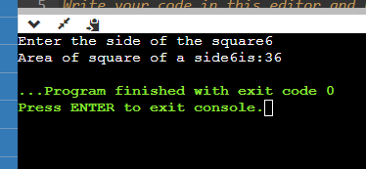

10.) WAP to calculate Area of Rectangle.

# include<iostream>

using namespace std;

int main()

{

int length,breadth,area;

cout<<"Enter the length of the rectangle";

cin>>length;

cout<<"Enter the breadth of the rectangle";

cin>>breadth;

area= length * breadth;

cout<<"Area of a rectangle"<<area;

return 0;

}

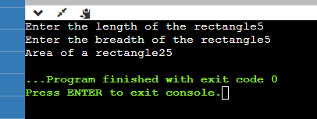

9.)WAP for finding remainder of division of 2 numbers.

# include<iostream>

using namespace std;

int main()

{

int num1,num2,remainders;

cout<<"Enter num1"<<endl;

cin>>num1;

cout<<"Enter num2"<<endl;

cin>>num2;

remainders=num1%num2;

cout<<remainders;

return 0;

}

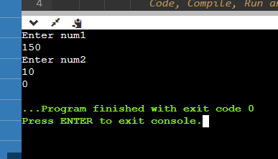

8.)WAP to check Leap Year.

# include<iostream>

using namespace std;

int main() {

int year;

cout<<"Enter a year";

cin>>year;

if(year%4==0 && year%100 != 0 || year%400==0)

{

cout<<year<<" is a leap year";

}

else{

cout<<year<<"is not a leap year";

}

return 0;

}

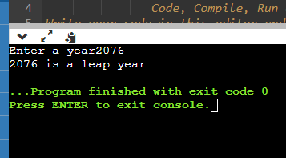

7.)Write a program, which takes two integer numbers as input and it shows their exchanged value. (Don’t use third variable)

# include<iostream>

using namespace std;

int main() {

int x ,y;

x=25;

y=35;

x=x+y;

y=x-y;

x=x-y;

cout<<x <<endl;

cout<<y;

return 0;

}

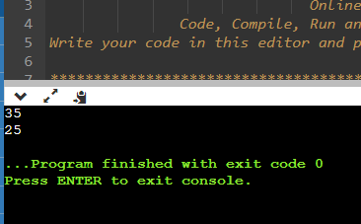

6.)Write a program which takes username as input and it greets to user with his name.

# include<iostream>

# include<string>

int main() {

std::string name;

std::cout << "Please enter a name:";

std::cin >> name;

std::cout << "Glad to meet you " << name;

return 0;

}

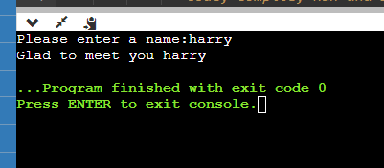

5.)Write a program that takes one input as number and it will display whether the number is +ve, -ve or zero. If the number is +ve, then it will display whether the number is odd or even.

# include<iostream>

using namespace std;

int main()

{

int a;

cout<<"Enter a number";

cin>>a;

if(a>0)

{

if(a%2==0)

cout<<"it is a positive even number";

else

cout<<"it is a positive odd number";

}

else if(a<0)

{

if(a%2==0)

cout<<"it is a negative even number";

else

cout<<"it is a negative odd number";

}

else {

cout<<"a is zero";

}

return 0;

}

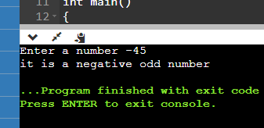

4. Write a program that takes three input of sides of a triangle. The program should indicate whether the triangle would be formed or not. If it can be formed it also indicates the type.

int main()

{int side1,side2,side3;

cout<< "Enter three sides of a triangle";

cin>>side1>>side2>>side3;

if (side1 + side2 <= side3 || side1 + side3 <= side2 || side2 + side3 <= side1)

cout<<"triangle cannot be formed";

if(side1 == side2 && side2 == side3){

cout << "\nThis is an Equilateral Triangle";

}

else if(side1 == side2 || side2 == side3 || side1 == side3) {

cout << "\nThis is an Isosceles Triangle";

else

cout << "\nThis is a Scalene Triangle";

return 0;

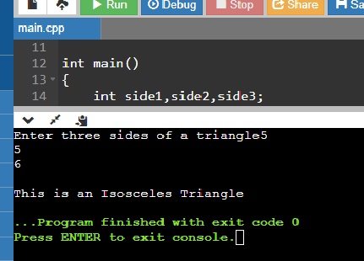

3.)Write a program that asks the user to enter a radius value and then compute the volume of a sphere with the input radius.

# include <iostream>

using namespace std;

int main()

{

int rad1;

float volsp;

cout<< "calculate the volume of a sphere";

cin>>rad1;

volsp=(4*3.14*rad1*rad1*rad1)/3;

cout<<"The volume of a sphere is :"<<volsp;

return 0;

}

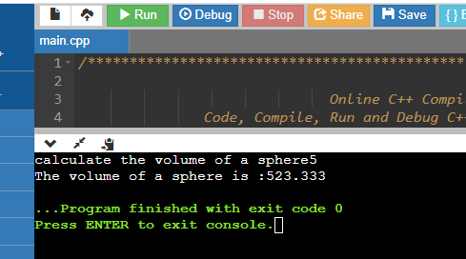

2. Write a program that generate the following output 10, 20, 19Use an integer constant for 10, an arithmetic C++ ASSIGNMENT operator to generate the 20, and a decrement operator to generate 19.

# include <iostream>

using namespace std;

int main()

{ int var = 10;

cout << var << endl;

var*= 2;

cout<< var-- << endl;

cout<< var << endl;

return 0;

}

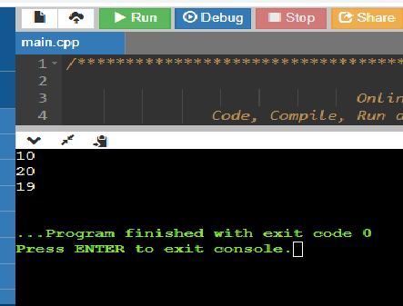

1.)Write a program to print “Hello World” on the screen.

#include <iostream>

using namespace std;

int main()

{

cout<<"Hello World";

return 0;

}

